(1 page maximum)

Title

Authors : John Snow, Winterfell university etc

Summary of the poster (Times New Roman, 12 pt)

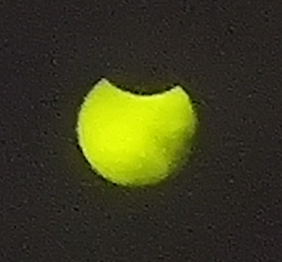
Figure 1: solar eclipse, 2021-06-10

Bibliography

